Tables creation and inserting rows:

CREATE TABLE sales (

customer_id VARCHAR(1),

order_date DATE,

product_id INTEGER

);

INSERT INTO sales

VALUES ('A',to_date('2021-01-01', 'yyyy-mm-dd'),1);

INSERT INTO sales

VALUES ('A',to_date('2021-01-01', 'yyyy-mm-dd'),2);

INSERT INTO sales

VALUES ('A',to_date('2021-01-07', 'yyyy-mm-dd'),2);

INSERT INTO sales

VALUES ('A',to_date('2021-01-10', 'yyyy-mm-dd'),3);

INSERT INTO sales

VALUES('A',to_date('2021-01-11', 'yyyy-mm-dd'),3);

INSERT INTO sales

VALUES ('A',to_date('2021-01-11', 'yyyy-mm-dd'),3);

INSERT INTO sales

VALUES ('B',to_date('2021-01-01', 'yyyy-mm-dd'),2);

INSERT INTO sales

VALUES ('B',to_date('2021-01-02', 'yyyy-mm-dd'),2);

INSERT INTO sales

VALUES ('B',to_date('2021-01-04', 'yyyy-mm-dd'),1);

INSERT INTO sales

VALUES ('B',to_date('2021-01-11', 'yyyy-mm-dd'),1);

INSERT INTO sales

VALUES ('B',to_date('2021-01-16', 'yyyy-mm-dd'),3);

INSERT INTO sales

VALUES ('B',to_date('2021-02-01', 'yyyy-mm-dd'),3);

INSERT INTO sales

VALUES ('C',to_date('2021-01-01', 'yyyy-mm-dd'),3);

INSERT INTO sales

VALUES ('C',to_date('2021-01-01', 'yyyy-mm-dd'),3);

INSERT INTO sales

VALUES ('C',to_date('2021-01-07', 'yyyy-mm-dd'),3);

CREATE TABLE menu (

product_id INTEGER,

product_name VARCHAR(5),

price INTEGER

);

INSERT INTO menu

VALUES (1, 'sushi', 10);

INSERT INTO menu

VALUES (2, 'curry', 15);

INSERT INTO menu

VALUES (3, 'ramen', 12);

CREATE TABLE members (

customer_id VARCHAR(1),

join_date DATE

);

INSERT INTO members

VALUES ('A', to_date('2021-01-07', 'yyyy-mm-dd'));

INSERT INTO members

VALUES ('B', to_date('2021-01-09', 'yyyy-mm-dd'));

SELECT * FROM sales;

SELECT * FROM menu;

SELECT * FROM members;

-- 1. What is the total amount each customer spent at the restaurant?

Query:

SELECT s.customer_id , SUM(m.price) AS total_amount

FROM sales s,menu m

WHERE s.product_id = m.product_id

GROUP BY s.customer_id;

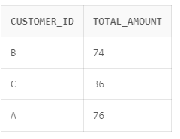

-- 2. How many days has each customer visited the restaurant?

SELECT customer_id, COUNT(DISTINCT order_date) AS days_visited FROM sales GROUP BY customer_id;

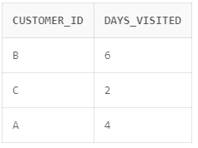

-- 3. What was the first item from the menu purchased by each customer?

WITH FirstPurchase AS (

SELECT

customer_id,

MIN(order_date) AS first_order_date

FROM

sales

GROUP BY

customer_id

)

SELECT

f.customer_id,

m.product_name AS first_item_purchased

FROM

FirstPurchase f

JOIN

sales s ON f.customer_id = s.customer_id AND f.first_order_date = s.order_date

JOIN

menu m ON s.product_id = m.product_id; 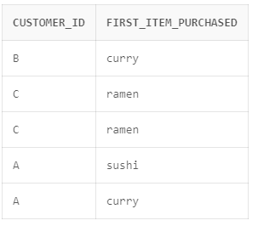

-- 4. What is the most purchased item on the menu and how many times was it purchased by all customers?

SELECT m.product_name AS most_purchased_item, COUNT(*) AS purchase_count

FROM sales s

JOIN menu m ON s.product_id = m.product_id

GROUP BY m.product_name

ORDER BY purchase_count DESC

FETCH FIRST ROW ONLY;

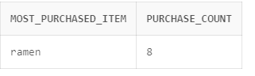

-- 5. Which item was the most popular for each customer?

WITH CustomerPurchaseCounts AS (

SELECT customer_id,

product_id,

COUNT(*) AS purchase_count

FROM

sales

GROUP BY

customer_id,

product_id

),

MaxPurchaseCounts AS (

SELECT

customer_id,

MAX(purchase_count) AS max_purchase_count

FROM

CustomerPurchaseCounts

GROUP BY

customer_id

)

SELECT

c.customer_id,

m.product_name AS most_popular_item

FROM MaxPurchaseCounts mc

JOIN CustomerPurchaseCounts c ON mc.customer_id = c.customer_id AND mc.max_purchase_count = c.purchase_count

JOIN menu m ON c.product_id = m.product_id

ORDER BY c.customer_id;

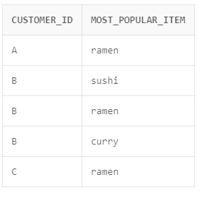

-- 6. Which item was purchased first by the customer after they became a member?

SELECT s.customer_id, m.product_name AS first_purchase_after_membership

FROM (

SELECT s.customer_id, MIN(s.order_date) AS first_purchase_date

FROM sales s

JOIN members m ON s.customer_id = m.customer_id

WHERE s.order_date >= m.join_date

GROUP BY s.customer_id

) first_purchase

JOIN sales s ON s.customer_id = first_purchase.customer_id AND s.order_date = first_purchase.first_purchase_date

JOIN menu m ON s.product_id = m.product_id;

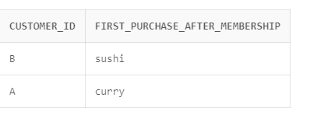

-- 7. Which item was purchased just before the customer became a member?

SELECT s.customer_id, m.product_name AS last_purchase_before_membership

FROM (

SELECT s.customer_id, MAX(s.order_date) AS last_purchase_date

FROM sales s

JOIN members m ON s.customer_id = m.customer_id

WHERE s.order_date < m.join_date

GROUP BY s.customer_id

) last_purchase

JOIN sales s ON s.customer_id = last_purchase.customer_id AND s.order_date = last_purchase.last_purchase_date

JOIN menu m ON s.product_id = m.product_id;

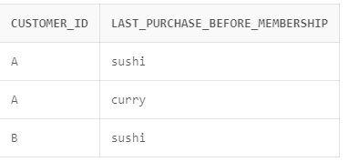

-- 8. What is the total items and amount spent for each member before they became a member?

SELECT m.customer_id,

COUNT(s.product_id) AS total_items_purchased,

SUM(m2.price) AS total_amount_spent

FROM sales s

JOIN menu m2 ON s.product_id = m2.product_id

JOIN members m ON s.customer_id = m.customer_id

WHERE s.order_date < m.join_date

GROUP BY m.customer_id;

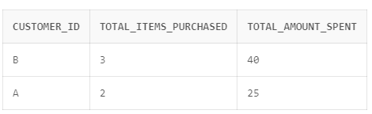

-- 9. If each $1 spent equates to 10 points and sushi has a 2x points multiplier - how many points would each customer have?

SELECT

s.customer_id,

SUM(

CASE

WHEN m.product_name = 'sushi' THEN 20 * m.price

ELSE 10 * m.price

END

) AS total_points

FROM sales s

JOIN menu m ON s.product_id = m.product_id

GROUP BY s.customer_id;

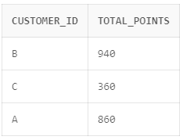

-- 10. In the first week after a customer joins the program (including their join date) they earn 2x points on all items, not just sushi - how many points do customer A and B have at the end of January?

SELECT

m.customer_id,

SUM(

CASE

WHEN s.order_date >= m.join_date THEN 20 * m2.price

ELSE 10 * m2.price

END

) AS total_points

FROM sales s

JOIN menu m2 ON s.product_id = m2.product_id

JOIN members m ON s.customer_id = m.customer_id

WHERE m.customer_id IN ('A', 'B')

AND s.order_date <= DATE '2021-01-31'

GROUP BY m.customer_id;

